Brandon Foreman

CEG 4110

10/11/2018

Homework 2

Main Features:

This program implements the model view controller and command design patterns. Moreover, it makes use of Android’s UI elements to provide a clock application. The application allows the user to add an analog or digital clock. These clocks are tied to a singular time. The time defaults the to the device’s current time, can be changed via date or time (seconds, minutes, and hours). Moreover, the application allows the user to undo and redo commands. A command is defined as adding a clock or changing the time. There is no limit to the amount of commands which can be executed. This means the user can make as many clocks as they wish and change the time as many times as they want.

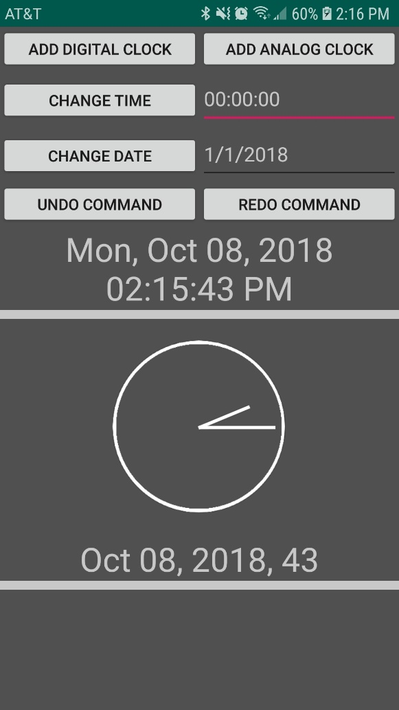

Figure 1: Example of the application in use

Implementing Design Patterns:

Model view controller was straightforward as a design pattern. I have worked with it before and am use the general premise of the design. However, one difficulty was working around Android’s already existent model, view, controller. The controller and model classes were cookie cutter MVC, but the views must conform to Androids implementation to function. Additionally, the command design pattern was also straightforward to implement. I use a UML diagram to plan the program out. So, when it came time to implement the design pattern, I already had things planned out. It was a simple plug and play. I would say overall; the design patterns are very useful. I have used MVC for large business applications and it has proved its usefulness. For an application of this size, it is a bit more difficult to see the usefulness. However, if it were to be expanded upon more, it be much more obvious the benefits it offers. Separation of concerns makes debugging and pinpointing problems in your code much easier as well.